BC Data & Information
cm_data_info.php — Basic Concepts
[image unavailable: define_ict_22.jpg]
Define ICT
[image unavailable: hw_sw_22.png]
Hardware and Software
[image unavailable: dvi_22.png]
Data vs Information

Data and Information

What's the difference?
Working with ICT needs a good understanding of the concepts of DATA and INFORMATION.
The problem is that, while almost everyone agrees on what Data is, a clear definition of Information does not exist.
People's understanding of information changes according to the field that they are working in.
For a computer scientist / ICT specialist we need to consider Information as being the result or output of processing data.
This gets a bit slippery though, because information can itself become data used in a new set of processing - making it hard to clearly define a difference between the two concepts.
What you have to do is think about the context of what you are looking at and how it is being used.
Often context is enough to turn a random number (e.g. 73) into a piece of information (you got 73 marks for the test).
That is "sort of" information, but is still lacking in meaning. If you take 73 and divide it by the total number of marks in the test you can calculate the percentage score you got for the test, which puts your mark on a clearly defined scale (0 - 100) and the information now clearly shows how well or badly you have done.
Adding rules that you have learnt turns this information into knowledge.
In this course the pass mark for all tests is 80% (it is much lower in your school).
If the 73 is actually 73% then the resulting knowledge gained from the rules of this course + the information of your mark is that you havefailed!
Wisdom is achieved when you understand the knowledge that you have failed, think about the course and spend more time practising quizzes and going over your notes before you take the next test. The wisdom has changed your actions and, hopefully, resulted in you passing the next test you take.
[image unavailable: montondile_point_left.png]
The goal of any information management system are: storing, sorting and getting information to the right people at the right time.

Why is information useful?

At first sight, asking 'Why is information useful' is like asking questions such as 'Is water wet?' and 'Is the sun a star?'. The obvious answer to these two questions is a simple 'Yes'.
The answer to why information is useful feels like it aught to be 'Because it is!'. Information is useful because it is information…
But this answer is not good enough.
We need to be able to give a more coherent, logically expressed argument as to why information is useful.
This short module helps plant the seeds of such an argument in your thinking - and hopefully you will continue to consider and expand upon these reasons throughout your life, discovering new ways that information reveals its value through your own experiences.
Back to the top of this Panel

What do we use information for?
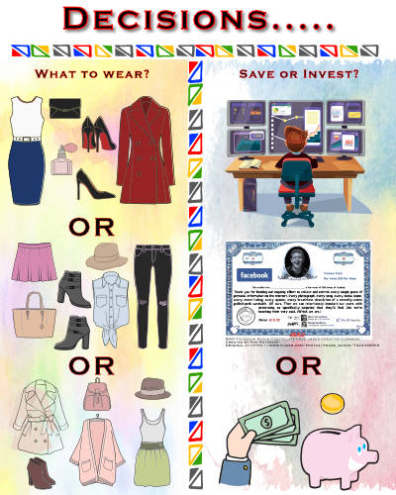
We use information for making decisions.
A bad decision can be disastrous. It can lead to unhappiness, poverty, relationship failure, or even death.
Generally we like to know as much as we can before making decisions - and the more important and significant the decision, the more we feel we need to know. What we are looking for is relevant, accurate, complete, high quality information to base our decision on.
Decisions can be as simple as what clothes to wear. Here we asks ourselves questions as to the weather (hot, cold, raining?), the nature of the occasion (formal, casual), who we want to impress & how - etc., etc.
The answers to all those questions is the information we base our choice of clothes on.
The decision about whether to invest your pension in a stock is far more serious. For this decision we do in-depth research. We want to find out about the company, what it produces, how well managed it is, what its prospects for the future are & how likely its stock price is to rise or fall.
When we have done our research and have the information we need we make the decision whether to invest or not.
The more important the decision, the more critical that the information it is based on is good.
Back to the top of this Panel

What makes information good?

Many people have spent a lot of time researching and thinking about what it is that makes information good. They have come up with lists of characteristics of good information that range from 4 - 7 items long. Most of them have very overlapping ideas.
We are going with the shortest list:
The 4 characteristics of good information are:
- Quality – information is accurate and reliable
- Completeness – enough information to allow you to make a decision but not so much to confuse the issue
- Timeliness – information must be available before the decision has to be made
- Relevance – the information must be relevant to the decision being taken.
If the information that you base your decisions on meets all of these requirements - and you end up making good decisions - then there is no doubt that information is useful!
Back to the top of this Panel
Here's a lesson that explains the difference between Data and Information in detail:
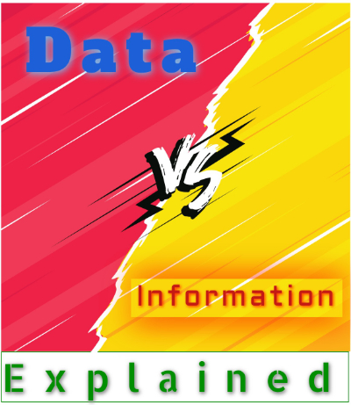

Practice Quiz
[image unavailable: pq_d_v_i.jpg]
This quiz lets you do random questions with no time limit. It will be slightly different each time you take it.

Practice Quiz - ALL QUESTIONS
[image unavailable: pq_d_v_i.jpg]
This quiz lets you do all the questions in the Data vs Information quiz.
You do not have to complete the quiz all at once, but can come back and continue where you left off.

FINAL QUIZ!
[image unavailable: qf_d_v_i.jpg]
This quiz lets you do random questions - with a time limit.
NB: This quiz can only be taken once and your marks are final.

Prev: Hardware and Software
Back to Top

End of Chapter

Video Links - Data vs Information
We have selected and curated a set of videos on YouTube related to your course.
These videos are not created or owned by us.
They may display advertising and in some cases may contain limited amounts of swearing.
Loading...
{ "service": "youtube", "method" : "playlist_videos", "options": { "max_count": 50, "max_cache_age": 15 }, "parameters" : { "playlist" :"PL2HRXufnVD1zIS7yvl7MGvoU2RgejGqOE", "channel" :"UCnNk0Zm9qZvPIGahKsyqH8A", "query" :"RapidWeaver" } }

Notes for this Module
What to look out for and do in this module...
The FAQs are not questions that are likely to appear in exam papers - they are real questions that most people ask about the content.

FAQs for this module
Questions on Data vs Information - and their answers...

Network Types FAQ
View the questions or type in the term you are looking for below…
No results were found

Is it possible for Information to also be data?
Yes.
Data gets processed into information.
If that information gets used as input for a new set of calculations and processing then the information is being used as data.

Any tips on telling the difference?
Data is collected.
Information is generated.
It is possible to have data without information.
It is not possible to have information without data.
Sometimes all that is needed to turn data into information is context.

